SIGNALS AND SYSTEMS
Manojkumar
192512298
Course Code: ECA0305
CO1 – EXPERIMENT 3
Experiment 3.1
Title: Addition and Multiplication of Two Sequences
Aim:
To perform addition and point-wise multiplication of two discrete-time sequences using MATLAB and to observe the resulting sequences.
Apparatus Required:
- Personal computer
- MATLAB software
Procedure:
- Open MATLAB and create a new script file.
- Clear the command window and workspace using clc, clear and close all.
- Define the sample index n = 0:10.
- Define the two sequences x1 = [1 2 3 4 5 6 7 8 9 10 11] and x2 = [11 10 9 8 7 6 5 4 3 2 1].
- Compute the sum y_add = x1 + x2.
- Compute the point-wise product y_mul = x1 .* x2.
- Plot x1, x2, the sum and the product using stem in a 2x2 subplot layout.
- Add grid, title, xlabel and ylabel to each plot, run the program and note the results.
Program:
% Addition and Multiplication of Two Sequences
clc;
clear;
close all;

% Sample index
n = 0:10;

% Sequence 1
x1 = [1 2 3 4 5 6 7 8 9 10 11];
% Sequence 2
x2 = [11 10 9 8 7 6 5 4 3 2 1];

% Addition of sequences
y_add = x1 + x2;

% Multiplication of sequences
y_mul = x1 .* x2;

% Plotting
figure;

subplot(2,2,1);
stem(n,x1,'filled');
grid on;
title('Sequence x_1(n)');
xlabel('n');
ylabel('Amplitude');

subplot(2,2,2);
stem(n,x2,'filled');
grid on;
title('Sequence x_2(n)');
xlabel('n');
ylabel('Amplitude');

subplot(2,2,3);
stem(n,y_add,'filled');
grid on;
title('Addition: x_1(n) + x_2(n)');
xlabel('n');
ylabel('Amplitude');

subplot(2,2,4);
stem(n,y_mul,'filled');
grid on;
title('Multiplication: x_1(n) * x_2(n)');
xlabel('n');
ylabel('Amplitude');

Output – Experiment 3.1:
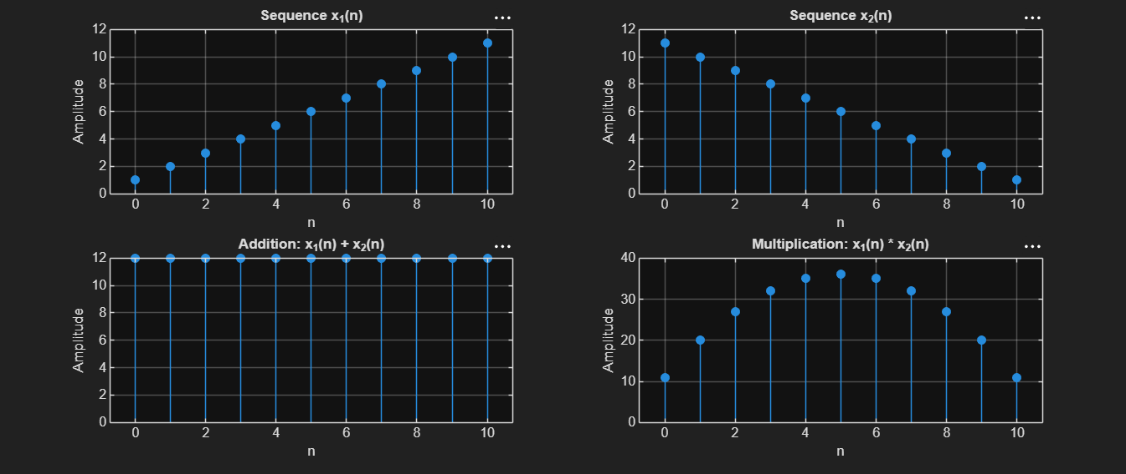
Result:
Two discrete-time sequences were generated and their addition and point-wise multiplication were performed successfully using MATLAB. The resulting sequences were displayed using stem plots, illustrating basic operations on discrete-time signals.

LABORATORY PERFORMANCE ASSESSMENT RUBRICS:

Objective | Assessment Criterion | Excellent – 4 | Good – 3 | Satisfactory  – 2 | Needs  Improve ment – 1 | Weight age | Marks given | Marks obtained
Calculate the energy and average power of given signals | Energy & Power Calculation | Correctly calculates signal energy and average power using appropriate mathematical expressions and MATLAB  implementation  independently. | Performs calculation s correctly with minor numerical or coding errors. | Performs basic calculations but requires guidance or has noticeable errors. | Unable to correctly calculate energy or power. | 25 | 2.5
Distinguish energy signals and power signals | Signal Classificatio n | Correctly classifies signals as energy or power signals based on calculated values and theoretical conditions. | Correctly classifies signals with minor errors or limited justificatio  n. | Performs basic classification but requires assistance or provides incomplete  justification. | Unable to classify the signal correctly. | 25 | 2.5
Implement numerical energy/power computation using MATLAB | MATLAB  Implementat ion & Numerical Analysis | Develops accurate MATLAB code, obtains reliable numerical values and appropriately selects the integration/summation interval. | Code and numerical results are mostly correct with minor errors. | Implements the basic computation with assistance or noticeable numerical errors. | Unable to impleme nt the required MATLA B  computat  ion. | 25 | 2.5
Compare analytical and simulated results | Theoretical Validation & Comparison | Accurately compares theoretical and simulated values, calculates deviation where applicable and explains discrepancies  clearly. | Provides correct compariso n with minor deviations  and | Provides basic comparison but validation or interpretatio  n is limited. | Unable to compare or validate the  results. | 25 | 2.5

